REFERENCE TO KINDS ACROSS LANGUAGES
Gennaro Chierchia

- The nominal mapping parameter:
  - Languages carry in what they let their NPs denote, in Chinese NPs re argumental (names of kinds) and can occur without determiners in argument position. Romance NPs are predicates and need a D in order to appear in argumental position.
  - Germanic and Slavic allow both predicative and argumental NPs. These types of languages are expected to be like Romance for the (singular count portion) and like Chinese for the (mass and plural portions).

1. Goals and Main Data

- Guiding principles (the Categorical Grammar type of Semantics):
  - Syntactic categories at the relevant level of representation, say LF, are mapped onto corresponding semantic types (thereby determining for each expression what its denotation is going to be).
  - Logical Forms are compositionally interpreted using a small set of universal rules (like functional application and abstraction).
  - Local type mismatches can be solved through a highly constrained set of universally available type shifting operations. These apply either in the lexicon or, possibly, as part of the compositional interpretation of phrases.

- Chierchia would like to do mainly three things:
Assess the status of the ongoing debate on bare nominal arguments (bare plurals and mass nouns) in English;
Extend the empirical coverage of current theories so as to address the differences between the distribution of bare nominals in English (and, more generally, Germanic) vs. Italian (and, more generally, Romance);
Develop and defend a ‘Neocarlsonian’ view of kind reference within a theory of bare arguments that has if not universal, at least broad crosslinguistic applicability.

- Carlson 1977: bare plurals refer to kinds
- A(mbiguity) Approach: Discourse Representation Theory (DRT Kamp 1981, Heim 1982) argues against Carlson 1977, saying rather that English bare plurals are ambiguous.
  - Bare plurals have two meanings, kinds and (weak) indefinites
  - The indefinites introduce variables that are bound by a generic operator or get existentially closed (if they are not raised)
  - Dominate view
- Neocarlsonian view: bare plurals do refer to kinds, but there is no need to appeal to a ‘stage’
  - Reconsider forgotten English data
  - Take data from Italian
  - Bare singular arguments are impossible in both English and Italian
  - Bare plurals and bare mass nouns are ungrammatical in French, yet bare plurals and bare mass nouns are fine in English

- Contrastive paradigm of bare singular and plural nouns in English and Italian
Bare NP generic VP/finite VP/stative VP
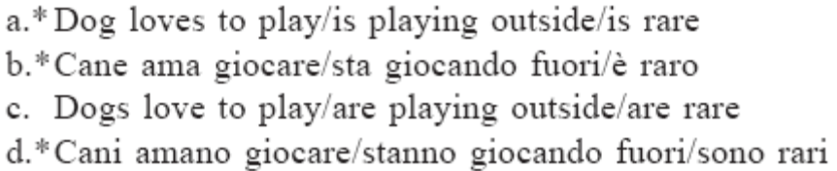

- The existential readings of bare plurals in Romance:
Plural forms of the indefinite article (Spanish)
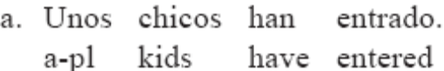
Partitive constructions (French, Italian)
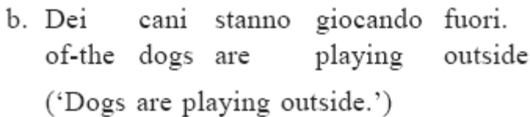
- The generic/kind readings of bare plurals in Romance:
Definite article (Italian)
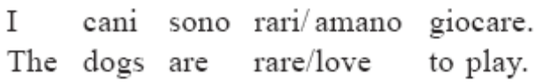

- The singular with a definite article also gives the generic/kind reading
Definite singular (French)
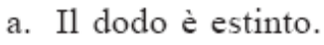
Definite singular (English)

- The semantic framework: Montague (mappings)
- NPs (common nouns) are predicates
NP ⇒ <e,t>
- DPs are arguments
DP⇒ e , GQ
- Generalized Quantifiers
GQ ⇒ <<s,<e,t>>,t>

- The idea is “take bare NP arguments to exist as a nominal analogue of, say, small clauses.”
Resistance: Stowell 1991, Longobardi 1994, 1996
Nouns need determiners in order to be arguments
Kinds are type e

2. An ontology for UG: the structure of the domain of discourse

Cont.
Plurality: Link 1983, Landman 1989 (standard view)
Mass nouns and kinds (not so standard)

2.1 Pluralities

- The domain of quantification
a, b, c are singular individuals/atoms
(singular definite NPs like John or that table or that kind of animal)
{ } are plural individuals
≤ orders the domain in the ‘subgroup/part of’ relation
( a ≤ {a,b} or John ≤ John an d Mary)
∪ join is the smallest plural comprising its elements
(a ∪ b ∪ b) = (a ∪ b)
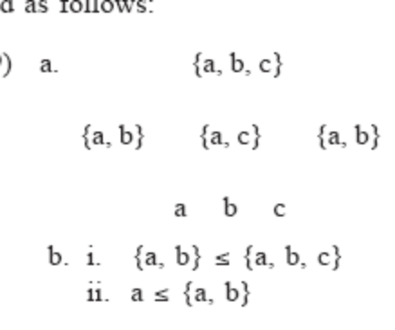
- Other definitions
Atoms are defined as the individuals which have only themselves as subgroups.
Dog is the characteristic function that is true of individual dogs.
Dogs is true of pluralities of individual dogs
Pluralization takes a set of characteristic functions of atoms and returns the corresponding sets of pluralities.

- Visual
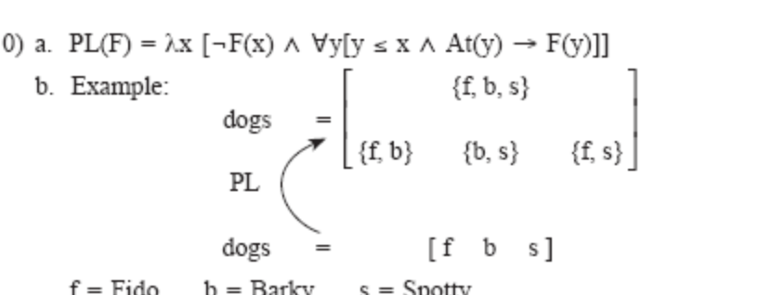
Characteristic functions are represented by enclosing their extensions in square brackets

- In this representation f, b, s are individual dogs, that is they are individuals of which the characteristic function DOG is true.
- The plural sets {f,b} {b,s} {f,s} and {f,b,s} are ‘dogs.’
- So, the PL(ural) of (F) is lambda x [ the characteristic function, not (F) of x and for all y such that [if y is a subgroup of x and the characteristic function At of y then F of y is true].
- The plural of dog means: give me x such that x is not a dog and for all y which are a subgroup of x , if y is an atom then y is a dog.

- The definite determiner (Frege-Russell), the iota operator
⍳ X = the largest member of X if there is one (else, undefined)
the dogs = ⍳ DOGS = the largest plurality of dogs {f,b,s}
the dog = ⍳ DOG = the only dog (if there is one) {f} or {b} or {s} depending on the context (as no atom is larger than any other this is only satisfied when there is one atom)

- Mass nouns are commonly assumed to be in a lattice structure like that for plurals except that the bottom members are not atoms.
- Chierchia instead assumes that mass nouns come out of the lexicon already pluralized.

- Lexical entry of mass nouns: a neutralization of the singular/plural distinction (Chierchia 1996, Gillon 1992)
(it appears that the square brackets indicate the characteristic function furniture applies to these elements?)
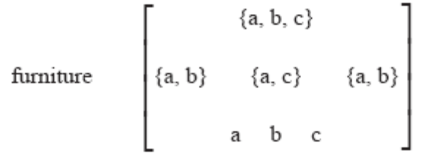
- Captures:
Mass nouns cant be pluralized because they are already plural
Mass nouns have no atoms and so they need to be individuated in order to count them
Economy: why have two different domains for count vs mass

- Doest expect skeptics to believe him but, follow along anyway. Ultimately it should end up consistent with the double domained view.

2.3. Kinds

“Kinds are generally seen as regularities that occur in nature… but their spatiotemporal manifestations are typically ‘discontinuous’” “Artifacts like chairs can be kinds as long as we can attribute a sufficiently regular behavior to them. (Carlson 1977:26, Krifka 1995)
- Any natural kind (dog-kind) will have a corresponding property (being a dog).
- The correspondence between (natural) properties and kinds suggests that there must be [functions] to get from one to the other.
- Fregean view of predication: each property has an individual counterpart.
The individual counterpart of common nouns are kinds
The individual counterpart of verbs are action types

- Property <s,<e,t>>
〚DOG〛= λw . DOG_{w}
- Kind <e>
〚d〛= dog-kind
- Down ⋂ Nominalizes:
Returns the kind corresponding to the characteristic function/property
⋂DOG = d
- Up ∪ Predicativizes:
Returns the characteristic function/property
⋂d = DOG
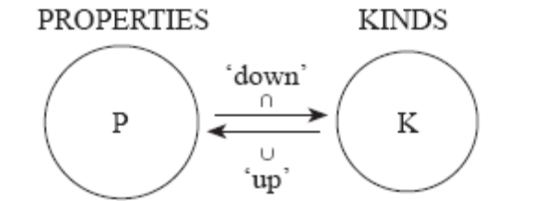
- The view of the domain of discourse above allows us to identify a kind as the totality of its instances which can be modeled as the set of dogs.
- This means we can model kinds as individual concepts of ‘functions from worlds into pluralities’ which identify classes of objects with regular behavior, they usually have a plurality of instances.
- A kind (like the dodo) may lack an instantiation in this world, then the kind function from worlds to pluralities is undefined.
- Ordinary individuals are a transworld line, which in every world picks out the manifestation of the individual.
- Does this mean a kind is a spidery individual across worlds of atoms which show a significantly regular behavior?

- The design of the domain
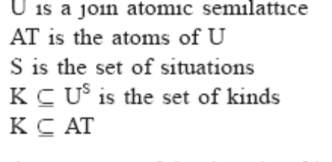
Unsorted types <e> as x, y
Sorted types <e??> as x_{σ}
Plain singular objects x_{o}
Pluralities x_{p}
Kinds x_{k}

Caveat: the set of equations in (14) is nontrivial, as the cardinality of U^{S} is larger than U, yet we require that kinds be a subset of U. To put it plainly, if K is too big a subset of U^{S} it might not fit into U.
Nonstandard set theories like Property Theory Chierchia 1984, Chierchia and Turner 1988 might work

- Up ∪ Predicativizes/ideal forming operator, gives a mass denotation?
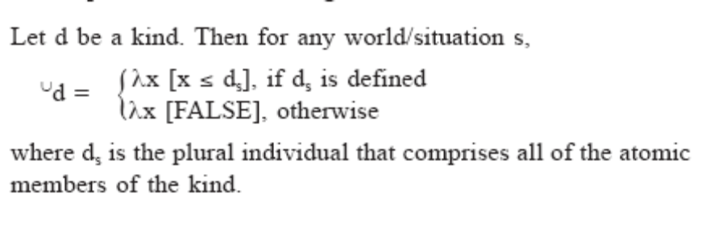
d is a kind, so for any world s, predicatize d returns whatever x if x is a subgroup of the kind d in that s, if the kind d in that s is defined, if its not defined then the predicativezation is null?

- The extension of the property corresponding to dog-kind is the ideal generated by the totality of dogs. Kind of like prototype theory. (Rosch)

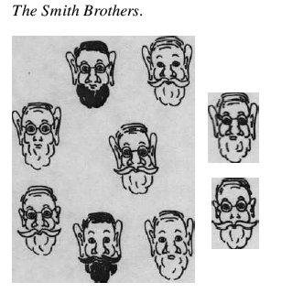
- A singular or a plural can be a good instance of a kind, meaning that the property corresponding to a kind comes out as being mass.

- Down ⋂ Nominalizes:
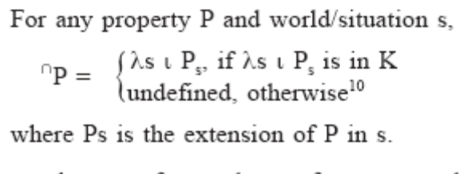
P is a property in a world s, down/nominalize P means for all s the largest extension of P in s if there is an s where the largest P in s is in the domain of Kinds K ? If the property doesn’t yield a kind then its undefined
In prose: a kind can be manufactured out of a property by taking the largest member of its extension (at a given world).

- The property of being a broken old shoe that Leo left behind is unlikely to have a corresponding kind.
- The Down ⋂ operation isn’t defined for singular properties since there would need to be a singular instance in every world.
- That the Down ⋂ operation only works on plural properties will be important.

- Some definitions
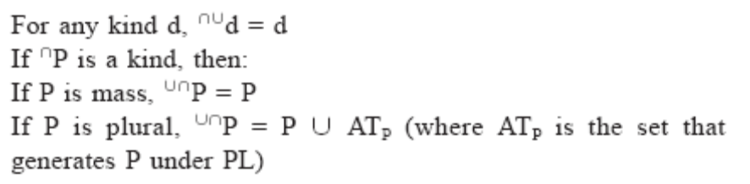
- Frege’s Metaphore 1891:
Properties are unsaturated (true or false of individuals)
Kinds are saturated (has a concrete manifestation)

- The down ⋂ nominalizer picks up the maximal set of individuals that bear that property in world w.
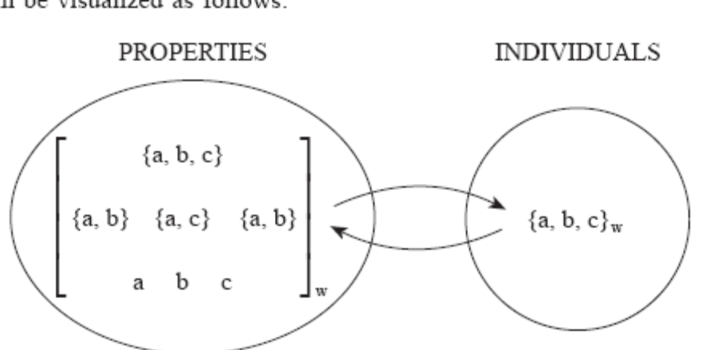

3. The nominal mapping parameter
- NP types found:
as restrictors of quantifiers (every man)
in predicate positions (John and Bill are doctors)
as arguments when used for kind reference

- A typology of NP denotations exploiting type shifting
 | [+argument] <e> | [-argument]
 |  | No Null D | Null D
[+predicate] <e,t> | [+arg, +pred] | [-arg, +pred]  French | [-arg, +pred]  Italian, Spanish
[-predicate] | [+arg, -pred]  Chinese | [-arg, -pred]

3.1. A Typology of Kind Reference

- In a language where nouns refer to kinds [+arg, -pred] every NP is type <e> and can be used bare as an argument.
Expect: Girl saw boy
- Determiners are quantifiers so they take a predicate and restrict it, thus determiners should be incompatible with kinds.
- Determiners do surface with kinds so Chierchia proposes a variant for languages which have kinds for NPs:

- Determiner for kinds DET’
a. DET’(x)(P) = DET(⋃x)(P)
b. Example, assuming dog to be of type <e> and barks of type <e,t>:
EVERY’ (dog)(barks) = EVERY(⋃dog)(barks)
- The up predicativizer is an ideal-former, it assigns the kind’s predicate counterpart a mass denotation.
- This means that all nouns are mass in these languages.
- Plural marking will be absent (the PL function has no argument for which its defined)
- Numerals also won’t be able to combine with nouns

- Chinese, Japanese
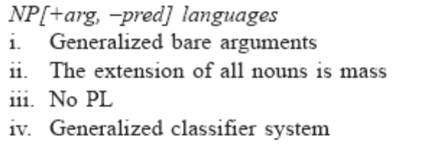
- Issues
- Syntax and semantics of modification
- The mass/count distinction might still be found (how vague are the minimal parts)

- In languages where nouns are predicates [-arg, +pred] the bare nouns cannot appear in argumental positions.
- Mass/count concerns the extension of predicates, then we expect to find such a distinction. Why?
- Plural marking will be active for the count portion
- Since bare nouns are impossible in French it must not have a null determiner.
- Null determiners could be licensed by proximity to a governor, as in Italian and Spanish. (Rizzi 1990)

An analysis of modification, and (pseudo)incorporation would allow for an analysis of kinds in a Heim framework? Esp if we don’t believe in licensing by proximity to governors anymore? Chierchia derives the same facts, but the governance and not moving away is a stipulation, rather than derived by the readings that we get… right? No, in other systems with incorporation we could expect that bare subjets be ungrammatical in a Chinese language, think about it more.

- Italian has a null head which is licensed by proximity.
a.* Bambini sono venuti da noi.
‘Kids came by us.’
b. Ho preso biscotti con il mio latte.
‘(I) had cookies with my milk.’

- In an [+arg, +pred] languages NPs are freely predicative or argumental through available type shifting operations, and lexical entries can denote kinds or predicates.
- If the NP is shifted by down, it becomes a mass denotation.
- Nouns will appear as bare arguments. Water is dripping on the floor
- If the NP is a pred <e,t> then it will have atoms in its extension and will be countable and need a Dº (not mass since mass are more economically derived by the +arg option, does this follow directly , it seems suspect)
- Nouns can be shifted up, but only with a plural since up isn’t defined for singulars.
- So bare plurals can appear in argument position.

- English, most Germanic
NP [+arg, +pred]
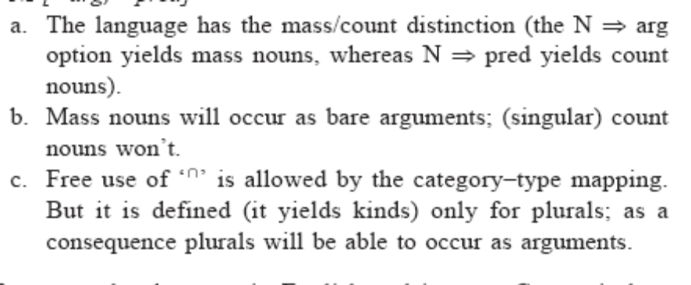
Why do we only have these sort of type shifting devices?

“suggested to me by I. Heim. Logically speaking, there might be a classifier language in which the distribution of bare arguments displays subject-object asymmetries.”

What about different readings in different positions?
The Nominal Mapping Parameter: minimal changes on what NPs can denote

Krifka 1995: the domain of interpretation is a lattice whose atomicity is unspecified.
Function (essentially a classifier) which applies to kinds k and associates with them an extension ATOM(k) which creates count noun denotations.
In the lexicon in English
In the syntax in Chinese
Problem: arguably classifier phrases exist in English (Selkirk 1977)
Problem: addresses differences in noun extensions not the distribution of bare arguments

3.2. Type Shifting as a ‘Last Resort’

Partee 1987:
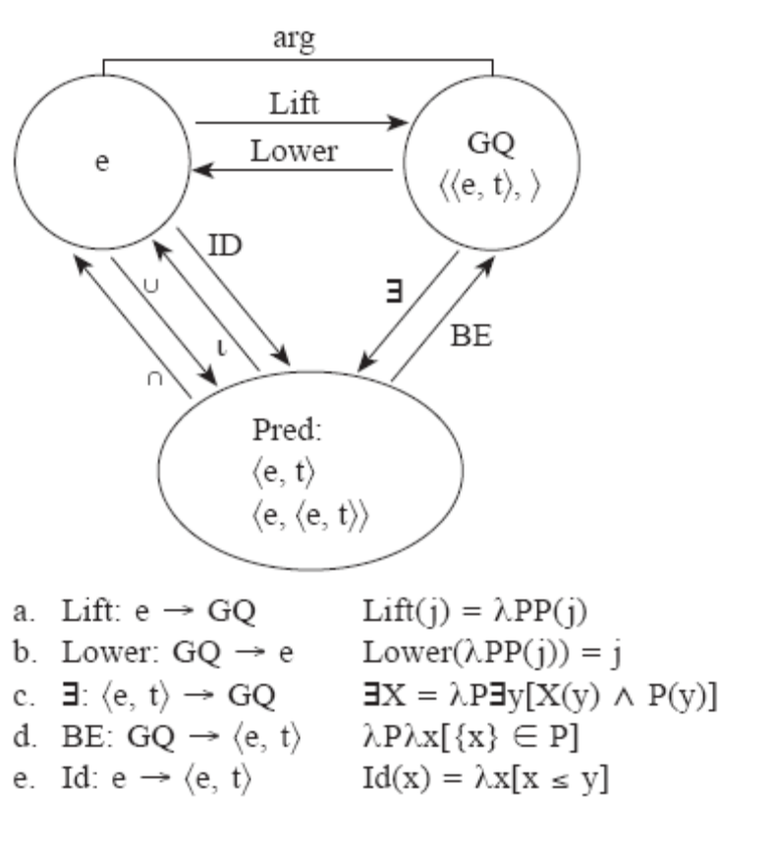
Lift: turns and individual <e> into a GQ<<e,t>,t> by taking all sets to which it belongs.
Existential closure ∃: turns a GQ <<e,t>,t> into a predicate <e,t>/<e,<e,t>>, traditionally the meaning of ‘a’
Montague’s BE: turns a predicate <e,t> into a GQ <<e,t>,> Partee argues that these operations are in the analysis of copular constructions.
⍳ : selects the greatest element from the extension of a predicate, typically the meaning of the definite article.
Id : the inverse of ⍳ is the ‘part of’ relation when the x is larger than 1.
Montague’s cap ⋀ cup ⋁ : switch back and forth between intensions and extensions, lambda abstraction over and application to the world variable.
⋀DOG = λw DOG_{w}
⋂ : combination of ⋀ and ⍳ restricted to kinds, turns entities in different worlds with a property <<e,t>,s> to individual kinds <e>, the intensionalized version of ⍳.

- Blocking Principle (Type Shifting as Last Resort)
Languages may encode different type shifting operations in determiners; if the operation is encoded in a determiner then it cannot apply covertly.
For any type shifting operation τ and any X:
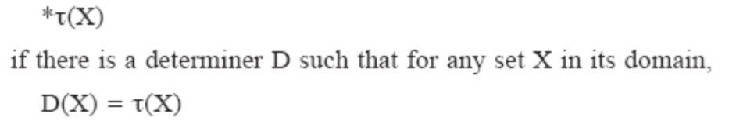
This predicts the presense of a language with the same types as English but with no articles, which could have bare arguments would occur freely and have a generic, definite, or indefinite meaning, depending, presumably, on the context. This is found in Russian:

- Russian bare arguments (a-c) have a mass/count distinction, (d) can have both definite, or indefinite meanings, (e) bare plurals can be used for kind reference (f) singulars can be used generically (like the English definite singular gloss)
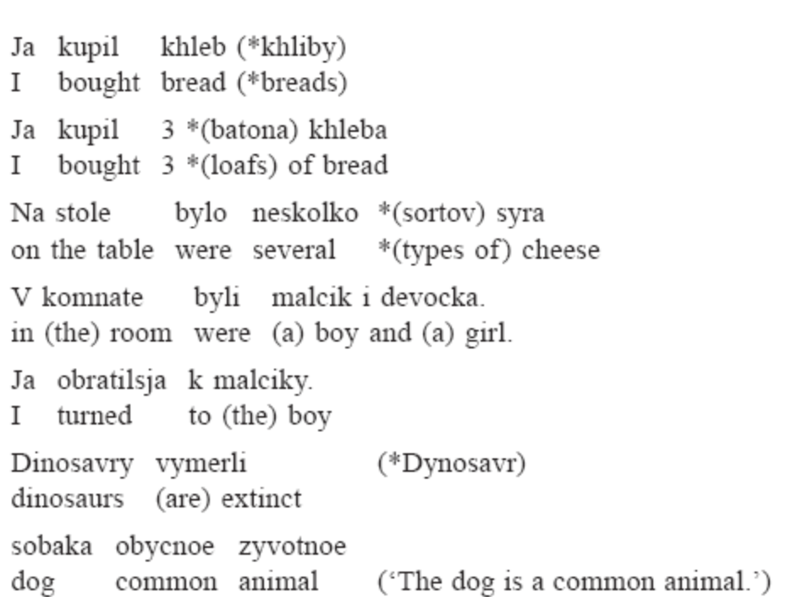

For further research:
Expect Russian bare nominals to have the same scopal properties as their English counter parts with over determiners.
Need to look at languages that lack only one of the determiners

4. Reference to kinds in English: twenty years later

- The alternative, dominant view:
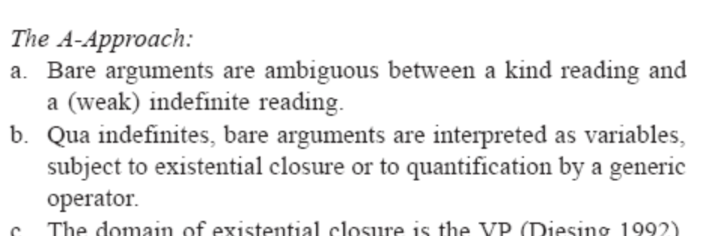

4.1. A Neocarlsonian Approach

- Carlson: kind selecting predicates
a. Gold is rare ⇒ rare (gold)
b. Dogs are widespread ⇒ widespread (⋂dogs)
Mass nouns are kind denoting and (plural) count nouns can be turned into names of kinds via ⋂.
- Bare arguments and indefinites also occur with non-kind selecting predicates
Generic contexts = universal reading
Episodic contexts = existential reading

- Kind readings in Episodic contexts
a. That kind of animal is ruining my garden.
b. [Pointing at the picture of a lion in a biology book] That is what you saw this morning at the zoo.

The Episodic predicate introduces a (local) existential quantification by the type shifting mechanism ‘Derived Kind Predication’ (DKP)”

“the source of existential quantification over instances of the kind in episodic sentences is an automatic, local adjustment triggered by a type mismatch.” (Chierchia 1998:364)

- Derived Kind Predication (DKP) for kind readings in episodic contexts (C31)
a. ∃x [⋃that kind of animal(x) ⋀ ruin my garden (x)]
b. ∃x [⋃that(x) ⋀ saw in the zoo (you, x)
c. Derived Kind Predication (DKP)
If P applies to objects and k denotes a kind then
P(k) = ∃x[⋃k(x) ⋀ P(x)]

Stopped on page 26 out of 68

4.2. Scopelessness
4.3. Suspension of Scopelessness

5. Objections
5.1. Wide Scope Effects
5.2. There-Sentences
5.3. Singular Generic ‘The’

6. Reference To Kinds In Romance
6.1. The Basic Patterns
6.2. The Account
6.3. Plural Generic ‘The’

7. Further Relevant Nominal Structures
7.1. Nominalized Adjectives
7.2. Proper Names

8. Conclusions: Semantic Variation And The Theory Of
Grammar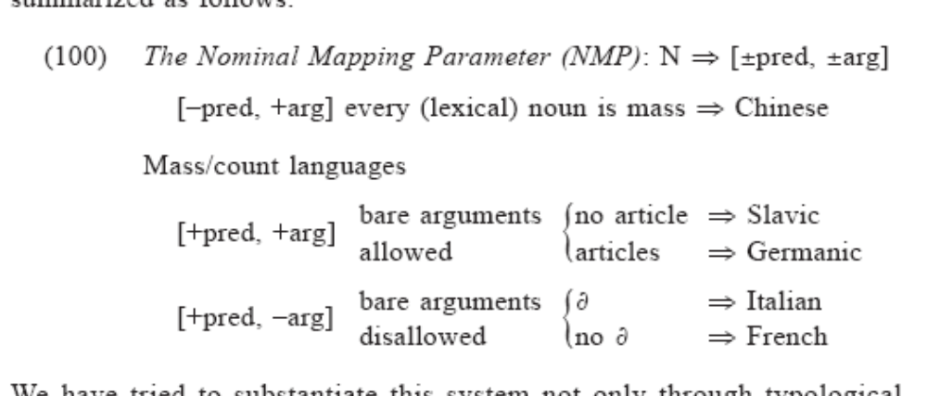

See also Gerstner and Krifka (1995), Krifka (1988), Wikinson (1991), Diesing (1992). Cf. also Longobardi (1994, 1996).
See Chierchia 1998:341 for explanation of strong/weak indefinites.
“an ontology is a data model that represents a set of concepts within a domain and the relationships between those concepts. It is used to reason about the objects within that domain.” wikipedia
This seems to assume that the plural morphology is part of the plural denotation rather than an agreement of some sort.?
“For the representation language I will adopt a language such as TY2 which contains variables over worlds. I assume that expressions are assigned an intensional type ás, añ, but that they are automatically provided with (distinguished) variables over worlds (which are notated as subscripts) which can be abstracted over (see, e.g., Groenendijk and Stokhof (1984) for details). When confusion is unlikely to arise, I will omit marking the world variable explicitly.”
This is a simplification from Chierchia’s earlier definitions but he still intends it to be cashed out in a theory of properties like that which he proposed in Chierchia 1984 or Chierchia and Turner 1988. This a theory that doesn’t work like the lattices that are standard adopted to represent the universes of entities.

